

**BAKU HIGHER OIL SCHOOL**

*Laboratory report*

*Course Electrical Health and Safety*

**Experiment Title: Electrical Safety in Offshore**

**Name of the student: Isa Jafarov**

**Group Number: 17.1**

**Lab report submitted: 08/05/2019**

**Supervisor:** [**Muhammad Salih**](http://lms.bhos.edu.az/user/view.php?id=383&course=1)

Table of Contents

Abstract 3

Introduction 3

Research 3

Causes of accidents in offshore industry 3

Solution 4

Safe Equipment 5

Guarding 6

Grounding 6

Circuit Protection Devices 6

Batteries 7

Extension and Cheater Cords 8

Methods of working and specific electrical design 8

Safe Work Practices 9

References: 10

Abstract

Working on an offshore oil and gas platform is considered one of the most dangerous careers. Dangerous offshore jobs are included in almost every list of hazardous professions and for good reason. The isolation, the extreme weather conditions, and the operating of heavy machinery for hours at a time can all take its toll, both physically and mentally.

Not to mention the highly combustible nature of the product that means a small leak can turn into a devastating explosion like Deepwater Horizon or [Piper Alpha](https://www.offshore-technology.com/news/anniversary-piper-alpha-offshore-safety-lessons-learn/), and claim the lives of several workers in an instant.

It is no wonder that accidents, injuries and even fatalities have been frequently recorded on offshore platforms. Spinal injuries, brain injuries, severe burns, limb amputations, broken bones and toxic inhalations from chemicals are common injuries listed on various legal accident claims websites.

Introduction

Offshore industries, nowadays, involve many different types of equipment and materials. Recognizing and controlling hazards is critical to preventing injuries and deaths. Several of these hazards are highlighted below:

* [Vehicle Collisions](https://www.osha.gov/SLTC/oilgaswelldrilling/safetyhazards.html#vehicles)
* [Explosions and Fires](https://www.osha.gov/SLTC/oilgaswelldrilling/safetyhazards.html#explosions).
* [Falls](https://www.osha.gov/SLTC/oilgaswelldrilling/safetyhazards.html#falls).
* [High Pressure Lines and Equipment](https://www.osha.gov/SLTC/oilgaswelldrilling/safetyhazards.html#high)
* [Electrical and Other Hazardous Energy](https://www.osha.gov/SLTC/oilgaswelldrilling/safetyhazards.html#electrical).

Electrical accidents, one the most dangerous one, accounts for thousands of deaths every year in offshore industry as well as onshore one. Workers might be exposed to uncontrolled electrical, mechanical, hydraulic, or other sources of hazardous energy if equipment is not designed, installed, and maintained properly. Further, administrative controls such as operating procedures must be developed and implemented to ensure safe operations.

Electrical accidents can result in serious injuries. Electrocution is the second leading cause of death on construction sites. Some common hazards at construction sites and other locations are overhead and buried power lines. An employer is required to address the possibility of electrical accidents in its safety and health program.

*Electric Shock*

You can get an electric shock when you come into contact with an electrical current. This shock can lead to a simple tingling sensation or even more severe injuries such as muscle contraction or system failure.

*Electrical Burns*

Electrical burns are usually the result of a severe electric shock. This can damage internal and external tissues, it can cause injury to organs and it may even cause death after prolonged exposure.

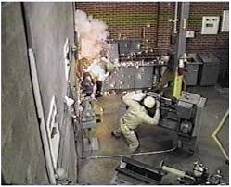*Electrical Fires*

While electric shocks and burns are employee-related accidents, electrical fires are invariably due to the work environment - usually caused by exposure to highly flammable materials.

Besides combustibles, Electronic Static Discharge (ESD) and electrical sparks may also cause an electrical fire and failure to immediately put it out can lead to serious injuries and environmental damage – causing anything from company downtime to death.

Research

There are some differences between offshore and onshore industries. Before starting research it is very important to understand what distinguishes offshore industry from others. What make offshore industry unique are

Logistics difficult

- Materials by Supply Boat

- Personnel Transfers by Chopper

- Escape in Chopper or in Survival Craft/Raft

- Offshore work costs 5x to 10x what it would onshore

Hostile Marine Environment

- Humid

- Salty and Corrosive

Extreme weather conditions

- Hurricanes and Typhoons

- 160 mph wind criteria

Marine Motions for Floater

- Pitch and Roll

- Lateral and Vertical Accelerations

Causes of accidents in offshore industry

Places of work generally have power nominally supplied at 230 volt (single phase) and 400 volt (3 phase) although some larger workplaces will receive electricity at a higher supply voltage. The information below relates to workplaces using 230 and 400 volt supplies.

The main hazards with electricity are:

* contact with live parts causing shock and burns
* faults which could cause fires
* Fire or explosion where electricity could be the source of ignition in a potentially flammable or explosive atmosphere, e.g. in a spray paint booth.

*Basics of Contact with Electricity*

It is the level of voltage the body is exposed to and the resistance to flow of electrical current offered by the body that determines the impact of exposure to electricity. The following factors determine the severity of the effect electric shock has on your body:

* The level of voltage
* The amount of body resistance you have to the current flow
* The path the current takes through your body
* The  length  of  time  the  current  flows  through your body

If a worker has come into contact with electricity the worker may not be able to remove themselves from the electrical source. The human body is a good conductor of electricity. If you touch a person while they are in contact with the electrical source, the electricity will flow through your body causing electrical shock. Firstly attempt to turn off the source of the electricity (disconnect). If the electrical source cannot readily and safely be turned off, use a non-conducting object, such as a fiberglass object or a wooden pole, to remove the person from the electrical source.

*Responsibilities*

Both employer and employee have some responsibilities, omitting which is likely to result in undesired accidents. For example:

Some of the employer’s responsibility are, for example, to ensure is extension cables and other flexible leads which are particularly prone to damage to plugs and sockets and to their connections are visually checked, maintained and where necessary replaced before using portable equipment. The ends of flexible cables should always have the outer sheath of the cable firmly clamped to stop the wires (particularly the earth) pulling out of the terminals

* Use the correct cable connectors or couplers to join lengths of cables together and do not allow taped joints.
* Electrical installations are installed and maintained by a competent person and checked regularly
* Socket Outlets are not overloaded by the use of adaptors
* Electrically powered equipment provided is suitable for use
* Fixed electrical equipment should have a clearly identified switch to cut off power in an emergency
* that portable equipment  labelled as being double insulated has had the live and neutral connected properly to the plug by a competent person unless the plug is of a molded type

It isn’t coincidence that lots of accidents are usually happen as a result of the fact that either workers or employers don’t do their responsibility properly.

Solution

Although it is nearly impossible to create an ideal industry where accidents do not happen at all and everything is completely safe, there are some solutions to implement in an attempt to make offshore industry safer. First step to produce solutions is to understand reasons of incident. According to researches, most electrical accidents result from one of the following three factors:

* Unsafe equipment or installation
* Unsafe environment
* Unsafe work practices

These accidents can be prevented with the use of

* safe equipment,
* guarding,
* grounding,
* circuit protective devices and
* Safe work practices.

Detailed information about each of them is given below.

Safe Equipment

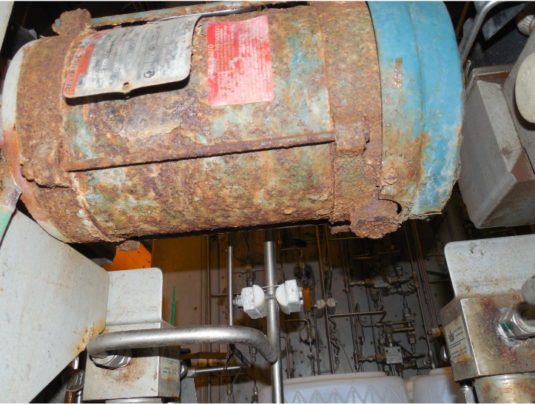Improperly installed or maintained electrical equipment greatly increases the risk of electrical accidents. For safe operation, all equipment must be installed according to the manufacturer’s instructions and used within its labelled capacity. Matching equipment to load expectations is an important aspect of electrical safety that should be performed by a qualified electrician.

All electrical conductors, components, and equipment used in the workplace must be considered acceptable by OSHA. This means components must be marked as tested by a Nationally Recognized Testing Laboratory.

All electrical workplace conductors and equipment must be deemed “acceptable” by OSHA. To be deemed acceptable, equipment must be marked as tested by a Nationally Recognized Testing Laboratory (NRTL), such as Underwriters Laboratory (UL) or Factory Mutual (FM). OSHA will look for these markings on the equipment to deem it safe. The equipment must be installed and used within its labeled capacity so as to not exceed the limitations of the equipment (e.g., putting the wrong switch for too much load, causing it to overheat).

Matching the equipment specifications to the load expectations of the installation will help prevent unsafe conditions. Always a qualified electrician should be used to perform all electrical work.

*Examples of these equipment devices are:*

* Watertight devices
* Ground fault circuit interrupters (GFCIs)
* Temporary power devices
* Modular power devices
* Motor control devices
* Wire management: strain relief, conduit, tubing
* Arc flash devices
* Lockout devices: plug locks, switch locks
* Cable protection systems

### Guarding

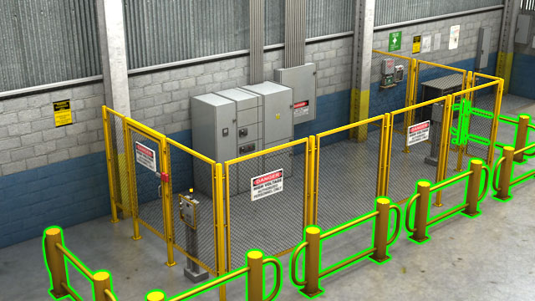Guarding involves locating or enclosing electrical equipment to make sure people don’t accidentally come into contact with its live parts. Effective guarding requires equipment with exposed parts operating at 50 volts or more to be placed where it is accessible only to authorized people qualified to work on it.

Proper guarding to enclose equipment helps prevent accidental contact with live components. To reduce the risk of electrical accidents, equipment with exposed parts running on fifty volts or more must be located in areas only accessed by authorized personnel.

Grounding

Grounding intentionally creates a low-resistance path that connects to the earth. This will prevent the buildup of voltages that could cause an electrical accident that could result from a worker being in the ground path. A properly designed grounding system creates a low-resistance path away from workers. When designed correctly, grounding substantially reduces the risk of an electrical accident if combined with safe work practices.

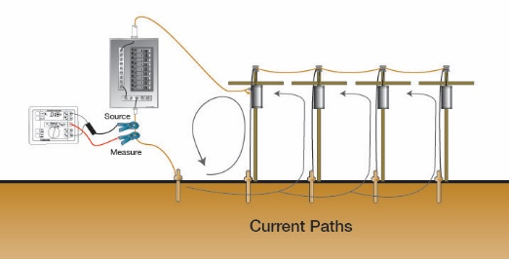

*Grounding falls into two types:*

* Service or system ground or
* Equipment ground

A service or system ground is designed primarily to protect machines, tools and insulation against damage. This involves the neutral or grounded conductor, typically white or gray, that is grounded at the generator or transformer at the building’s service entrance.

Equipment grounding helps protect the operator by furnishing a second path for current to travel if a fault occurs. It will react much faster to prevent shock and serious injury to the operator. This is accomplished by use of circuit protection devices.

Circuit Protection Devices

These devices limit or stop the flow of current automatically in the event of a ground fault, overload, or short circuit in the wiring system. Common examples include fuses, circuit breakers and GFCIs.

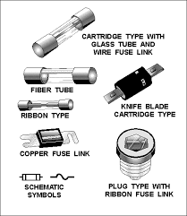

Fuses and circuit breakers open or break the circuit automatically when too much current flows through them, and will melt or trip to open the circuit. These are slow acting devices that are used primarily for protection of conductors and equipment. They typically do not open fast enough to prevent shock or further injury. They prevent overheating situations from occurring that result in damage to the conductors or equipment.

GFCIs are used typically in wet locations, construction sites, factory maintenance, and other high-risk areas to protect the equipment user. These devices react much faster than fuses and circuit breakers to interrupt the flow of current before shock and injury results.

The proper use of circuit protection devices such as GFCIs, circuit breakers, and fuses, is essential for the safety of electricians. Circuit protection devices stop the flow of electricity should equipment short circuit and in the event of overloads or ground faults.

*GFCI protection is provided in a variety of devices, including:*

* Receptacles
* Sensing modules
* In-line cords and
* Cord outlet modules

### Batteries

Batteries store sulfuric acid electrolytes and electrical energy that may cause an explosion and personal injury if suddenly released.

[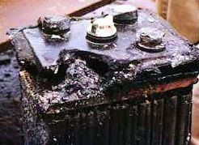](https://www.oshatrain.org/courses/images/909/909_1_8_batteries_bsee.jpg)

When working with batteries:

* Cover batteries stored in boxes as sources of emergency power with a non-conductive rubber mat under the lid of the box.
* Fit battery boxes with vents directed away from air inlets and sources of ignition.
* During the change out of batteries, avoid naked flames and sparks in the immediate vicinity of the battery.
* Chock batteries in their storage boxes to prevent movement under tow.
* Do not lift batteries by their terminals.
* Have plenty of ventilation, wear all required protective clothing and eyewear, remove jewelry, and exercise caution.
* Specialty or non-conductive tools should be considered when performing maintenance on batteries.
* Follow the manufacturer's instructions for testing, jumping, installing, and charging all batteries.
* Only use spirit (alcohol) thermometers when measuring a battery’s temperature.
* All lead acid, NiCad, and lithium batteries should be disposed of in accordance with all local, state, and federal regulations. Recycle these batteries as universal waste under the company’s waste management plan.

### cordExtension and Cheater Cords

Power tools and portable electrical test equipment may or may not be rated for use in classified areas. They are equipped with standard non-explosion-proof plug ends, making it sometimes necessary to use an extension cord when plugging into explosion-proof receptacles.

Due to the hazard of arcing electrical equipment or connections when plugging in this equipment, use the following practices:

* Use only electrical equipment that is approved for use in a classified area.
* Make sure a Hot Work Permit has been issued and the atmosphere has been tested to ensure flammable, gas-free conditions.
* Connections should be taped to prevent them from separating.
* Connections made with explosion-proof ends should be made outside of the classified areas.
* The last connection made should always be plugging the cheater cord into the explosion-proof receptacle.
* Break the connection at the explosion proof receptacle first when the job is completed.
* Remove from service and destroy extension cords that are frayed, taped, or otherwise damaged.
* Use extension cords only for temporary situations.

Methods of working and specific electrical design

For offshore oil and gas production to be a safe and profitable endeavor, a consistent power supply is required. Additionally, as automation has woven its way into offshore operations, reliable control systems are becoming increasingly important to that effort. However, while the electrical and control systems of an offshore platform are somewhat similar to those in an onshore facility, special considerations must be made when designing and implementing them.

List of electrical design considerations specific to offshore platforms:

* space limitations,
* weight limitations,
* safety hazards,
* Corrosive marine environment.

These require electrical and control systems that can be relatively segregated, lightweight, water-resistant, and corrosion-resistant. Given the work environment and production requirements on the platform, the power grid must be reliably continuous while remaining safe and cost-efficient. Modularity provides an avenue for maintaining an always-on electrical system, allowing operators to more rapidly respond to maintenance and replacement needs with less impactful downtime. Redundant standby options in not only power generation but also programmable logic controllers (PLC) can also contribute, particularly while [finding a balance between reliability and cost](http://imechanica.org/node/13535).



Programmable logic controllers (PLC)

While electrical generation and distribution — including grids, power plants, and generators — is a major priority in designing and implementing an offshore facility, control systems also plan an important role. These systems have the potential to increase drilling efficiency, improve energy use, and provide a safer working environment. Drilling control systems can help automate bit feed as well as monitor pressure, position, and power distribution of the drilling equipment. Other functions such as water treatment, gas compression, and helicopter refueling can also be connected to control systems to improve their efficiencies. Finally, safety systems can benefit from control system integration. Pressure protection, fire suppression, and emergency shut-down procedures can be automated and monitored from a central hub to reduce the number of containment and other operational incidents.

Some government agencies such as the U.K.’s Health and Safety Executive (HSE) Offshore Division provide significant [guidance documents on offshore platform electrical and control systems](http://www.hse.gov.uk/offshore/controlsystems.htm). The HSE, for example, provides guidance on explosion-protected electrical equipment, unearthed electrical distribution systems, and high-voltage motors used in hazardous areas in order to reduce the risk of major platform accidents. The U.S. Bureau of Safety and Environmental Enforcement (BSEE) also provides a few insights into electrical system safety through its [Potential Incident of Noncompliance (PINC) inspection items](http://www.bsee.gov/Inspection-and-Enforcement/Enforcement-Programs/Potential-Incident-of-Noncompliance---PINC/), including mandates on rechargeable battery systems, lighting fixtures, and wiring and grounding.

Safe Work Practices

Electrical accidents are largely preventable through safe work practices. Examples include:

* De-energizing electrical equipment before inspection or repair,
* Lockout/tag out procedures to prevent accidental or unexpected startup of electrical equipment,
* Keeping electric tools properly maintained,
* Exercising caution when working near energized lines and
* Using appropriate personal protective equipment.

Lack of lockout/tag out procedures and use of proper isolation equipment is a leading cause of unsafe work practices. The first step before beginning any inspection, repair or maintenance of any equipment is to follow the written procedure to isolate all energy sources to prevent accidental startup of the equipment.

Only trained authorized employees should maintain electrical equipment. One individual lockout device should be issued to each authorized employee performing the activity, and no two lockout devices should match. Authorized employees should be the only ones to apply and remove their device.

The responsibility of an electrical safety program should not be taken for granted. It should be assigned to someone with a complete knowledge of electricity, electrical work practices and the appropriate OSHA standards to administer the program. It is everyone’s responsibility to follow the program to make it effective.

References:

<https://www.grainger.com/know-how/safety/electrical-hazard-safety/advanced-electrical-maintenance/kh-3-most-common-causes-electrial-accidents>

<https://www.osha.gov/SLTC/oilgaswelldrilling/safetyhazards.html#electrical>

<http://sites.ieee.org/houston/files/2016/01/8-Offshore-Platform-Design-Apr-7-8.pdf>

<https://www.oshatrain.org/courses/mods/909m1.html>

<https://www.tpctraining.com/blogs/news/the-3-causes-of-electrical-accidents>